**Do it in Group of 3 or 5 and try to upload each one on its GITHUB account and Share with me its link via email.**

**Due Date 06 Oct 2021 11:59PM**

**Write your Group Members name Id in Contact Page.**

**I will take VIVA in office Hours.**

**If someone do alone then its VIVA chances are less.**



WEB ENGINEERING

ASSIGNMENT NO 01

Prepared By:

Zohaib Anjum 30106(BSSE)

Urooj Fatima 30251(BSSE)

ILSA KHAN 30175(BSSE)

Muhammad Ammar Khan 30080(BSSE)

Abbas Akhter 30270(BSSE)

Q1: What is Image Map Tag, Picture Element and How we can add image in background without using CSS? Give one Example of Each.

<!DOCTYPEhtml>

<htmllang="en">

<head>

    <metacharset="UTF-8">

    <metahttp-equiv="X-UA-Compatible"content="IE=edge">

    <metaname="viewport"content="width=device-width, initial-scale=1.0">

    <title>Document</title>

</head>

<bodybackground="images.jpg"width="1280"height="746">

</body>

</html>

</html>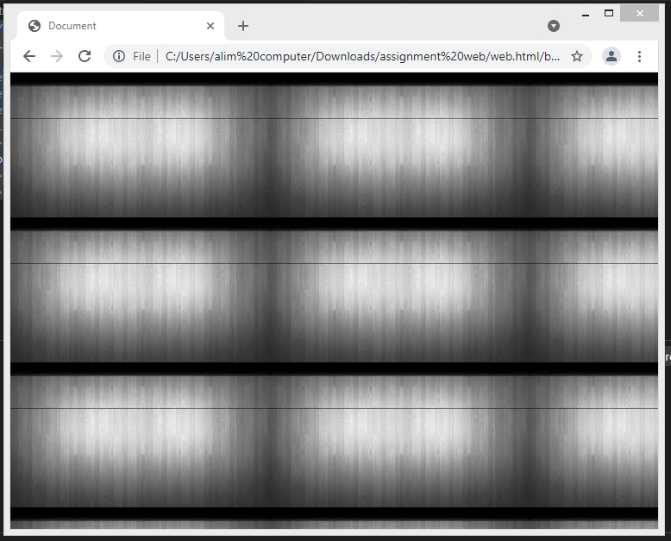

Q2: List down all tags categories in HTML5 and HTML4?

## HTML List Tags

|  |  |  |
| --- | --- | --- |
| Tag | Description |  |
| [<ul>](https://www.w3schools.com/tags/tag_ul.asp) | Defines an unordered list |  |
| [<ol>](https://www.w3schools.com/tags/tag_ol.asp) | Defines an ordered list |  |
| [<li>](https://www.w3schools.com/tags/tag_li.asp) | Defines a list item |  |
| [<dl>](https://www.w3schools.com/tags/tag_dl.asp) | Defines a description list |  |
| [<dt>](https://www.w3schools.com/tags/tag_dt.asp) | Defines a term in a description list |  |
| [<dd>](https://www.w3schools.com/tags/tag_dd.asp) | Describes the term in a description list |  |

**categories of HTML tags?**

* Paired Tags.
* Singular Tags.
* Meta Tags.
* Formatting Tags.
* Page Structure tags.
* Control Tags.
* Interactive Tags.

Q3 Difference between HTML and XHTML?

The difference between HTML and XHTML is that Hypertext Markup Language (HTML) is a hypertext and markup programming language used to create web pages.

Extensible Hypertext Markup Language (XHTML) is a hypertext and markup programming language derived from HTML.

1. HTML is known as Hypertext Markup Language. On the other hand, XHTML is known as Extensible Hypertext Markup Language.
2. HTML is a hypertext and markup language used to create web pages. On the other hand, XHTML is a hypertext and markup language formulated from HTML.
3. HTML is generated from Standard Generalized Language (SGL). On the other hand, XHTML is generated from HTML.
4. Nest Tags are not used in HTML. On the other hand, Nest tags are used in XHTML.
5. HTML doesn’t have a case sensitivity nature. On the other hand, XHTML is extremely case-sensitive.
6. HTML codes can either be written in uppercase or lowercase. On the other hand, XHTML codes can only use lower case.
7. HTML doesn’t have strict measures to follow. On the other hand, XHTML has strict measures to follow.--5

**The Most Important Differences from HTML**

* <!DOCTYPE> is mandatory
* The xmlns attribute in <html> is mandatory
* <html>, <head>, <title>, and <body> are mandatory
* Elements must always be properly nested
* Elements must always be closed
* Elements must always be in lowercase
* Attribute names must always be in lowercase
* Attribute values must always be quoted
* Attribute minimization is forbidden

Q4: Try to Make Four Html Pages with Following properties:

**Page 1 Home Page=** What is Introduction of Your Web Page, Use Semantic Tags and meta tags also you have some link to redirect to specific topic with in page, This page must also include header footer and navigation bar of other pages,

Home page must have title, Favicon, Some proper styles color font no CSS.





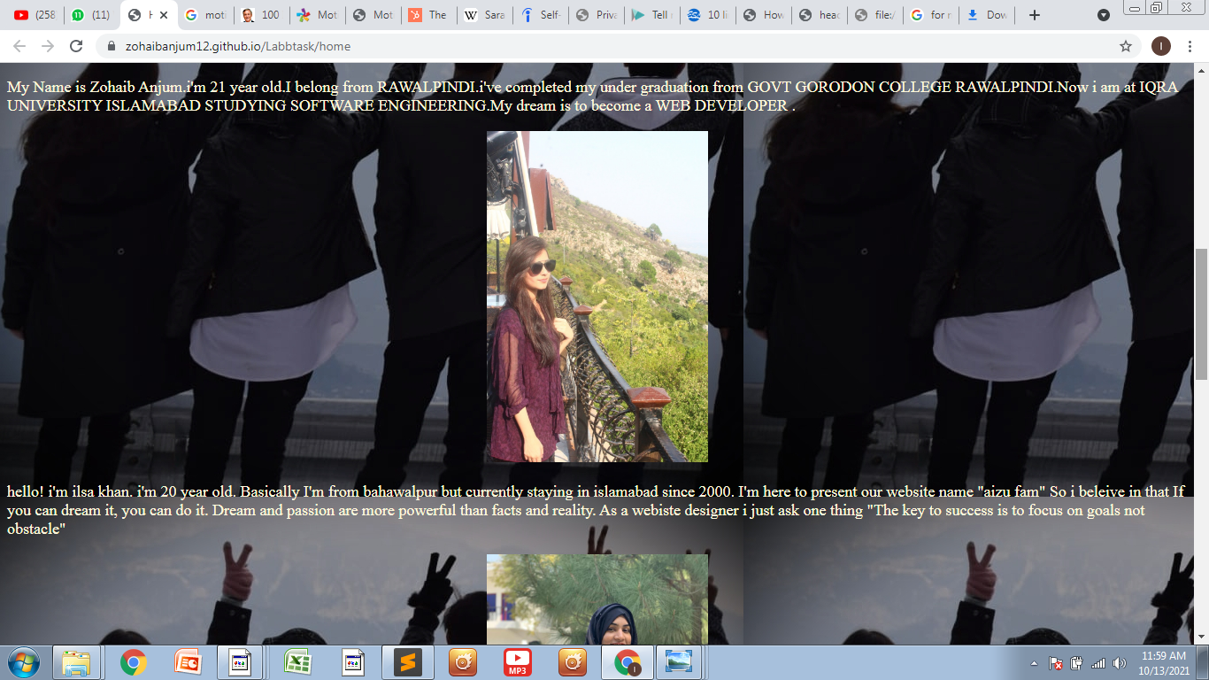

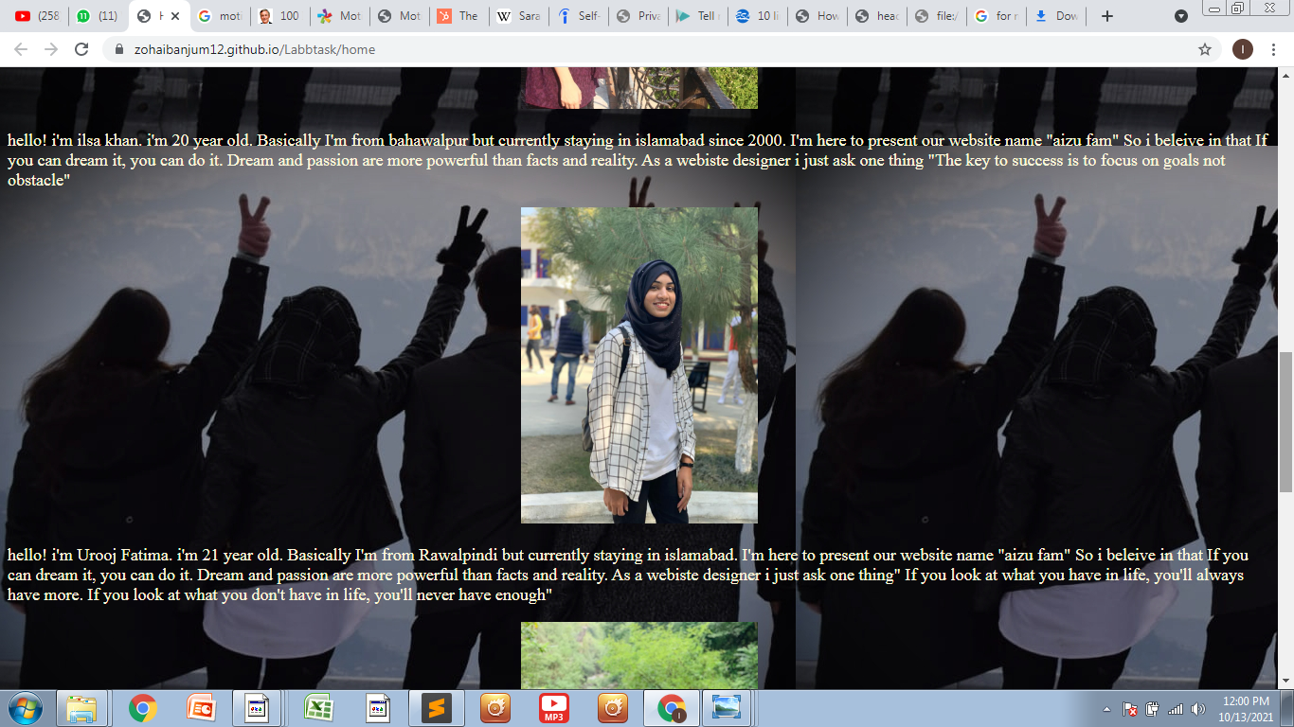



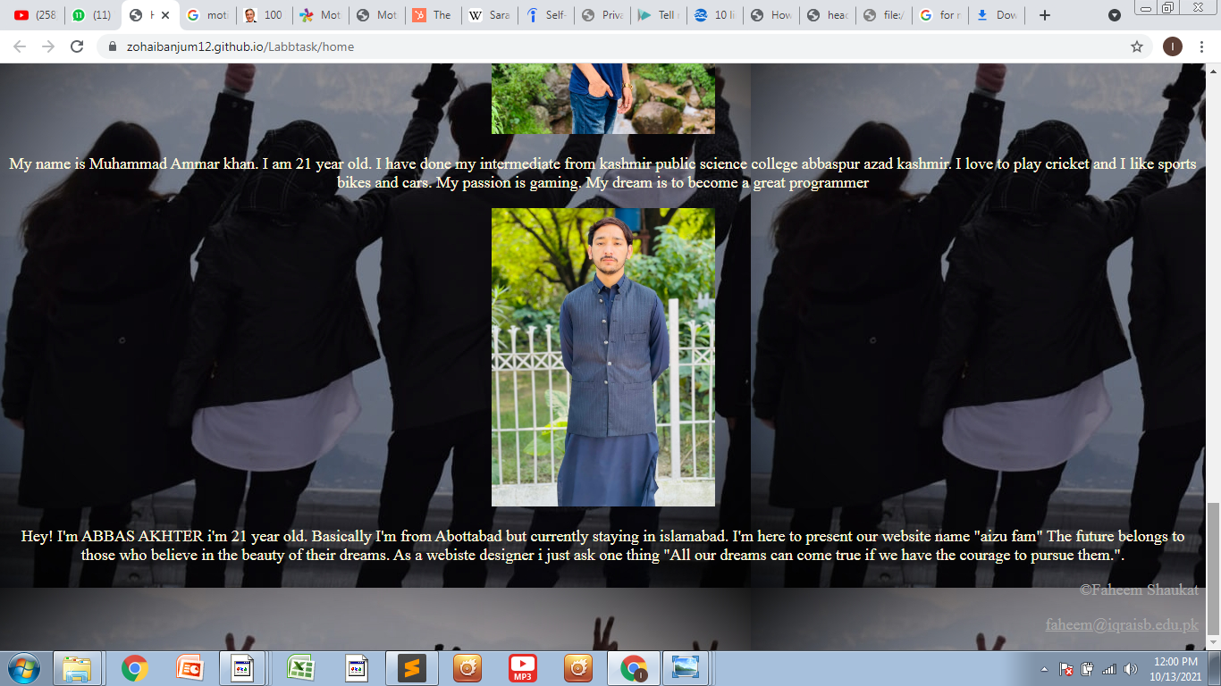

**Page 2 My Hobbies=** Add order and un-order List of Hobbies in this page also add you favorite Game (Online and Physical) detail. Font color text size must be same color scheme like home page.

Try to make Two tables in which first you add favorite hobbies then favorites games of yourself and your friend also. Try to make table color full

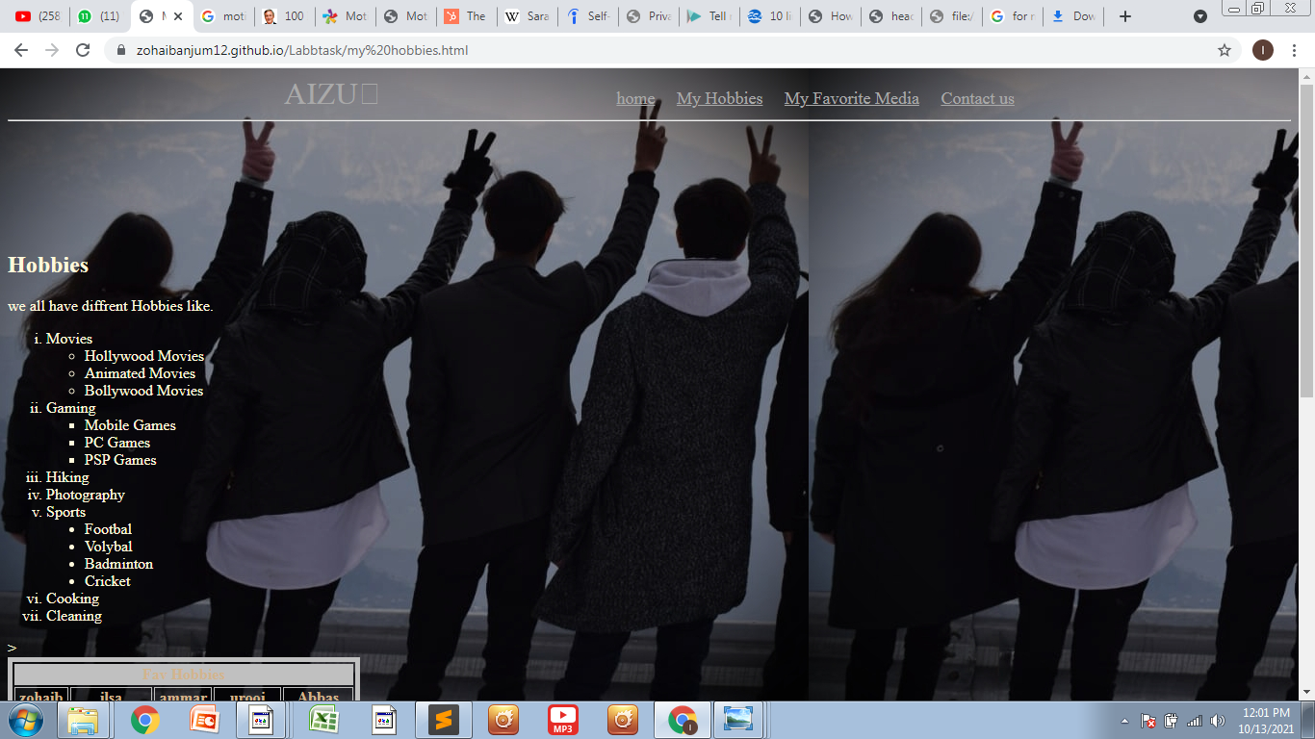

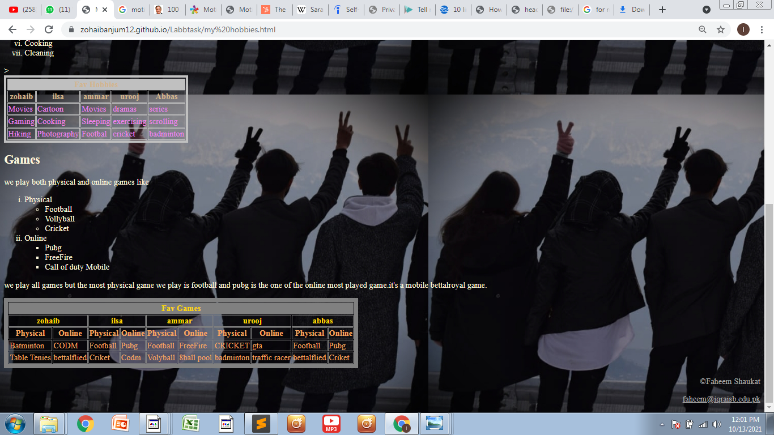

**Page 3 My Favorite Media=** Add social media, YouTube video and other stuff (Pic). Here you can use Div tag or table tag to divide webpage in two portion and in one side we can see your favorite posts of social media and on other side we can see you favorite videos link at least 5.

Use some fixed picture some from online web live links

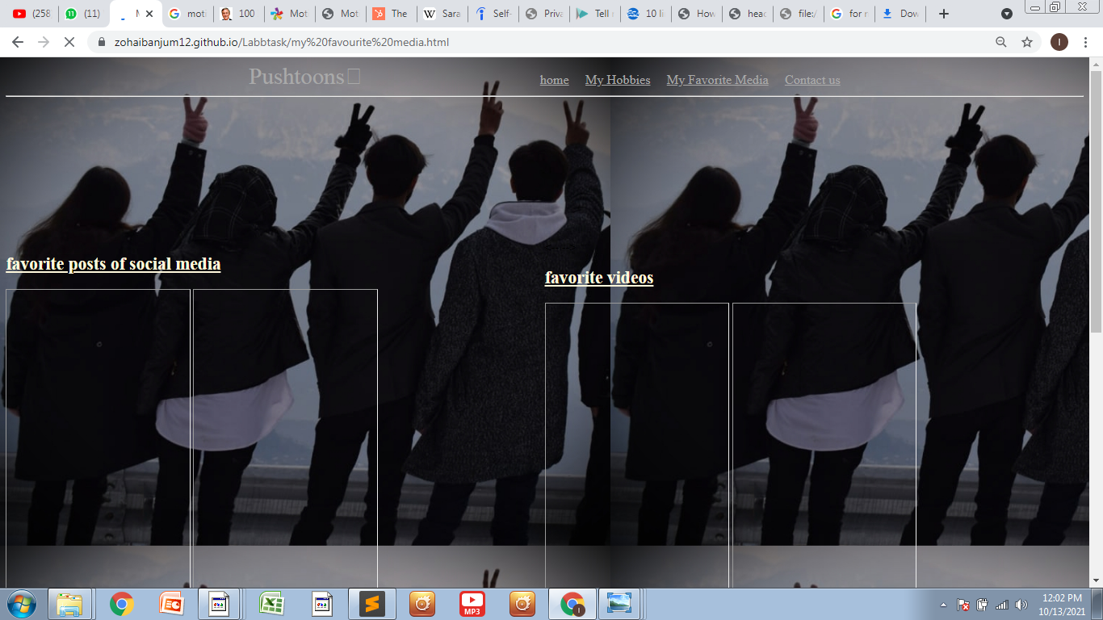

**Page 4 Contact Here=** You have to add your Name, Designation, Email, Contact# and Location of your office in Google Map

*Try to use all tags your read in class + lab and if not try to read by yourself.

*I am expecting unique formatted with unique content colorful website.

*First 3 Question solutions must also be uploaded on GitHub with Assignment No.1 Solution title doc file.

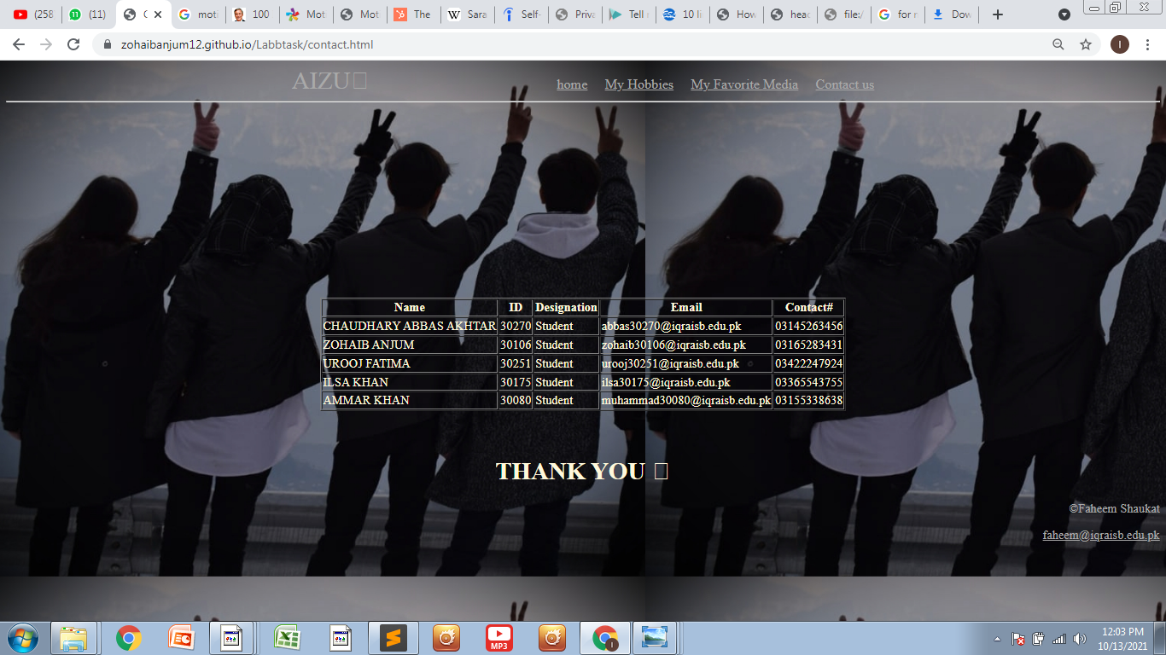

**VISIT LINKS**

**Page 1 Home Page=**https://zohaibanjum12.github.io/Labbtask/home

**Page 2 My Hobbies=** <https://zohaibanjum12.github.io/Labbtask/my%20hobbies>

**Page 3 My FavoriteMedia=**https://zohaibanjum12.github.io/Labbtask/my%20favourite%20media

**Page 4 Contact Here=**\*https://zohaibanjum12.github.io/Labbtask/contact.

**____________________________**

**THANKYOU**